Bonafide Certificate and Student Identity Card of the applicant are enclosed herewith.

The Bonafide Certificate has been issued by Chaitanya Deemed to be University, Hyderabad, confirming that the applicant is currently pursuing B.Tech in Computer Science and Engineering.
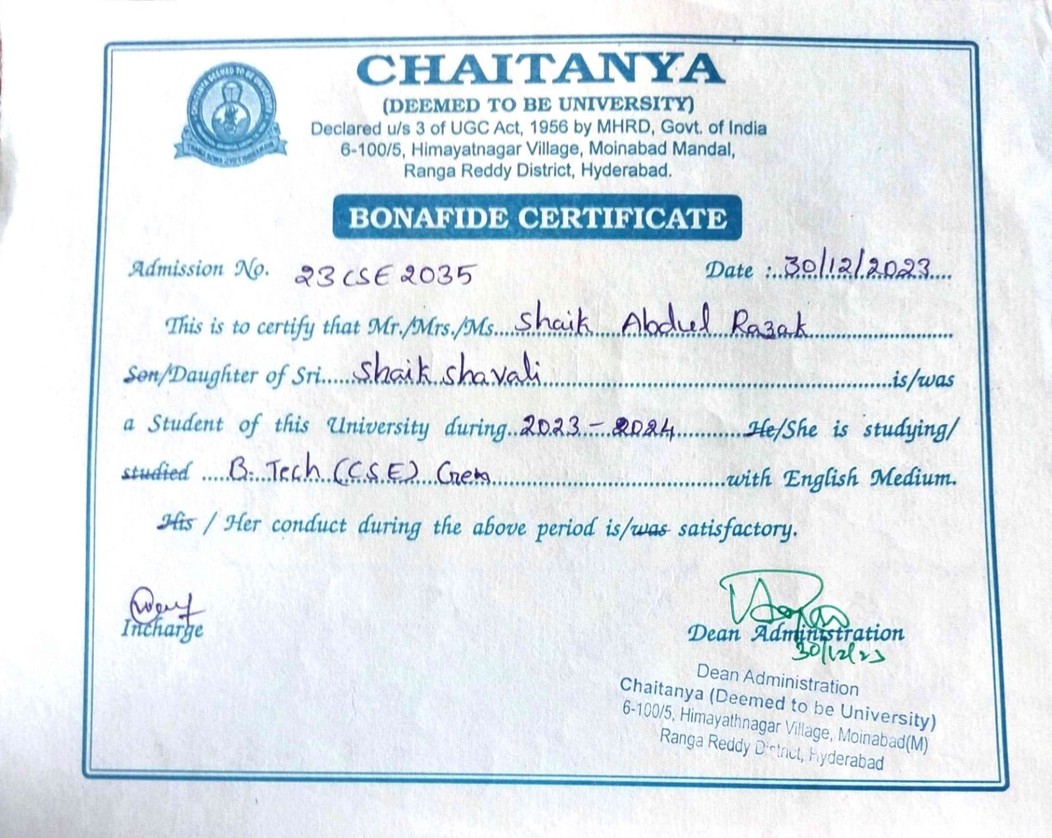

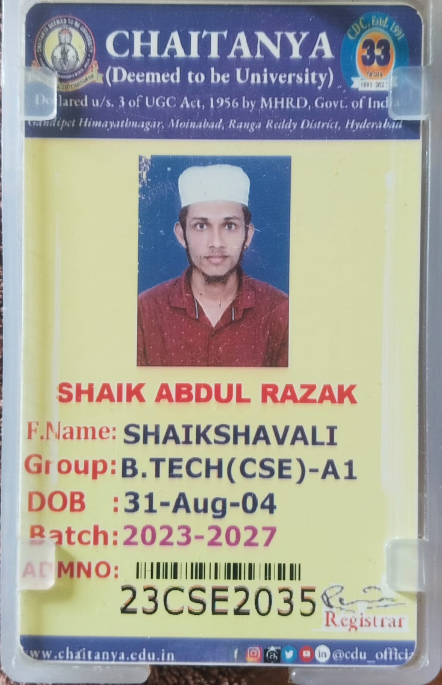

All documents have been self-attested to confirm their authenticity.

This document is submitted as per the guidelines of Nutrihub, ICAR-IIMR.

